**Project 2**

**Team:**

Devika Ashwathappa

Sherry Javed

Matthew Belevski

**Proposal:**

Does weather affect the congestion and congestion of roads and crowding on public transport during peak hour traffic in the afternoon (4pm to 6pm)?

**Data Sources:**

**Congestion on all roads during 2031 PM peak 2016**

<https://data.gov.au/data/dataset/audit-2019-congestion-on-all-roads-during-2031-pm-peak>

These data represent average weekday transport performance during PM peak (4pm to 6pm). Note that any network links below relevant daily volume thresholds are not included. This is why some sections will appear missing or broken, and some links are isolated.

**Crowding on suburban trains roads during 2031 PM peak 2016**

<https://data.gov.au/data/dataset/audit-2019-crowding-on-suburban-trains-during-2031-pm-peak>

These data represent average weekday transport performance during PM peak (4pm to 6pm). Note that any network links below relevant daily volume thresholds are not included. This is why some sections will appear missing or broken, and some links are isolated.

**Weather in Australia**

<https://www.kaggle.com/jsphyg/weather-dataset-rattle-package>

This dataset contains about 10 years of daily weather observations from many locations across Australia.

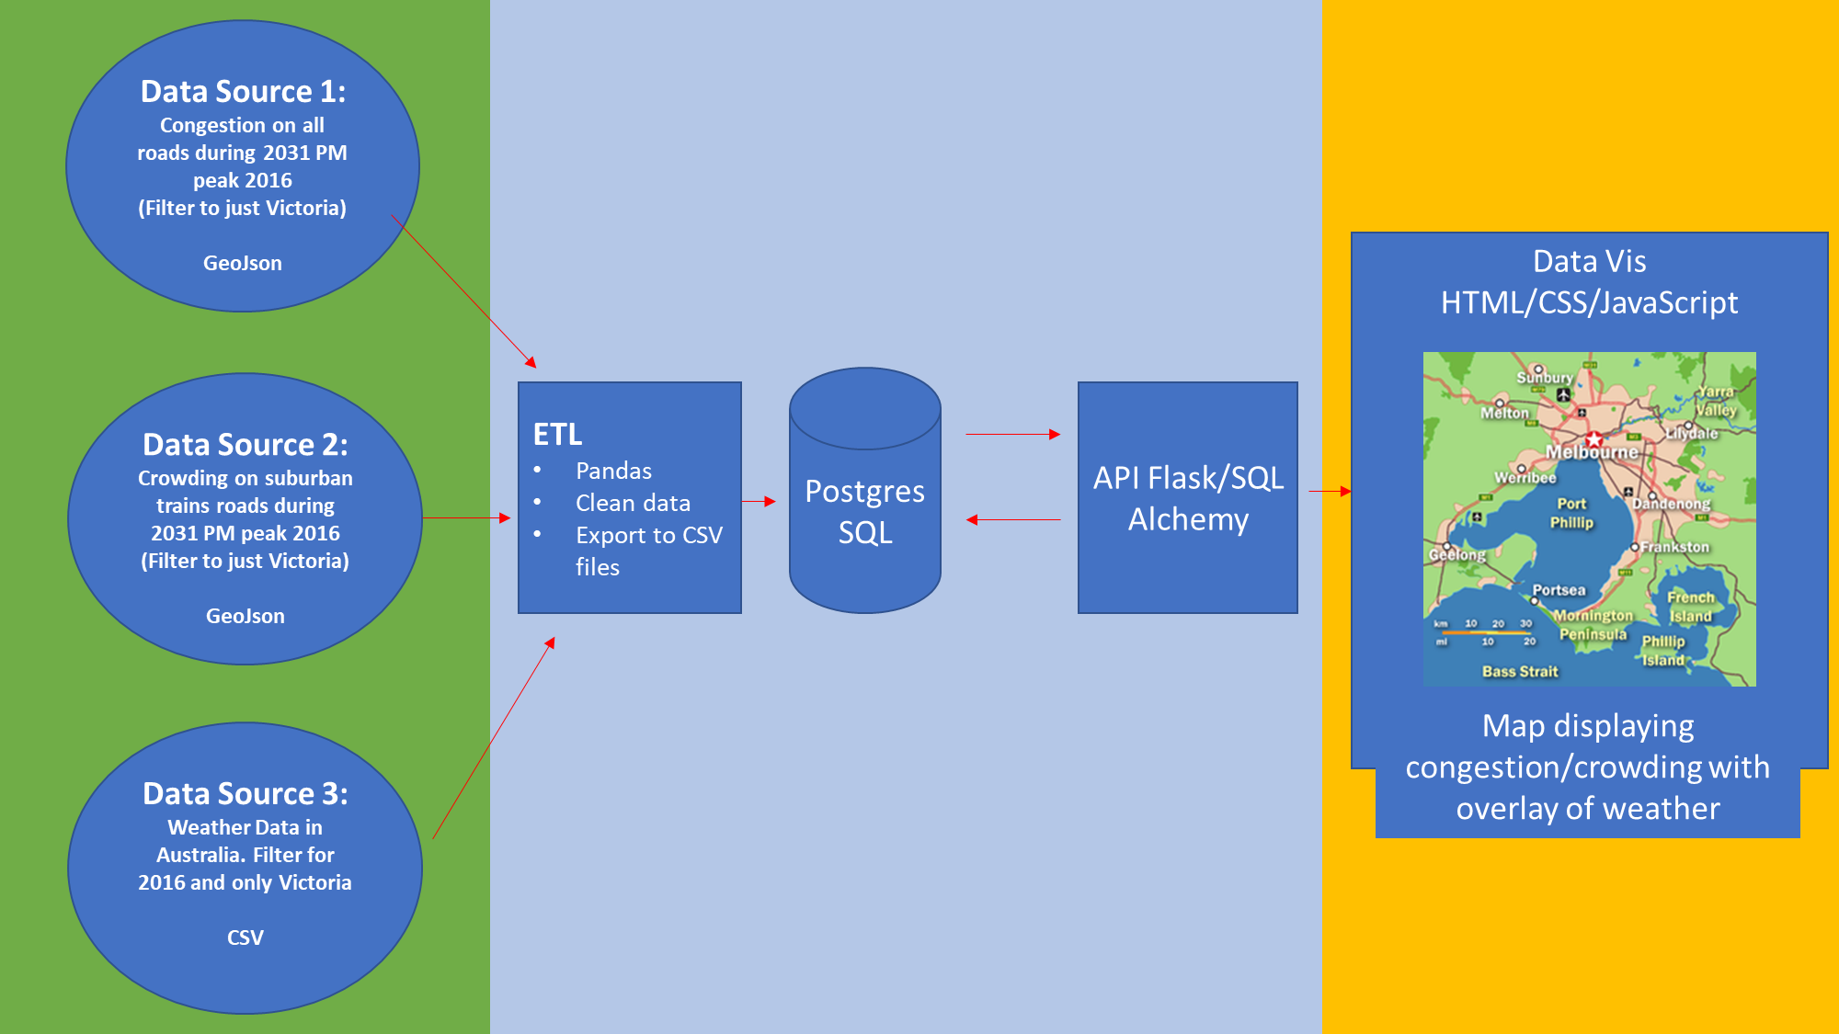**Project Workflow**